TASK 2
CREATED TABLE
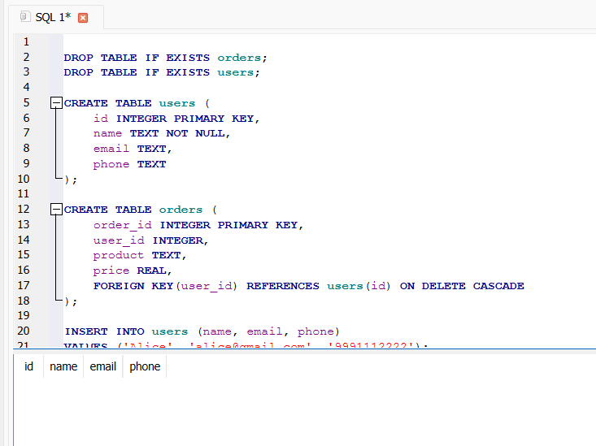

INSERTED VALUES INTO THE TABLE
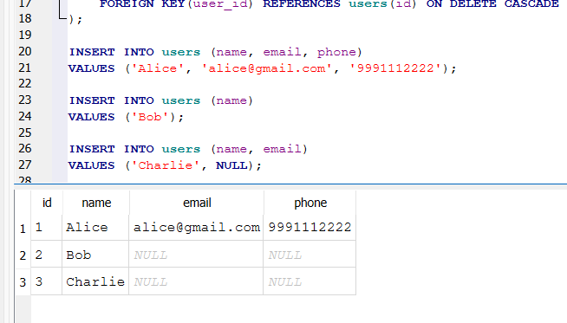

Handle missing values using NULL or default
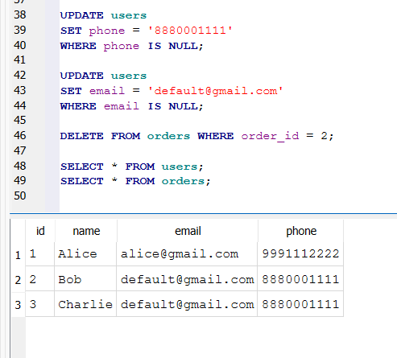
DELETED with WHERE conditions
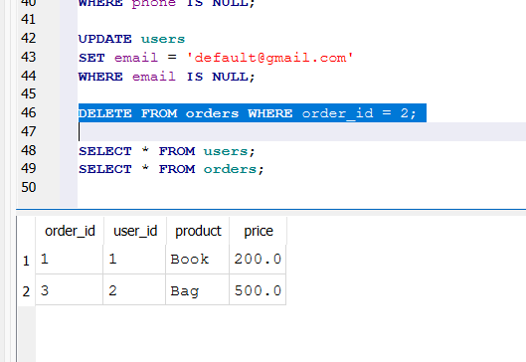

UPDATED with WHERE conditions

